In this lab, we’re going to examine how lenses and mirrors work with the ray model of light.

Part 1: Converging and Diverging Lens Simulations
In order to examine ray tracing diagrams, and we will look at how varying object distances and sizes– as well as varying focal lengths – changes the size, orientation, and location of a focused image. The simulation for the behavior of a “thin lens” can be found here:
http://physics.bu.edu/~duffy/HTML5/Lenses.html
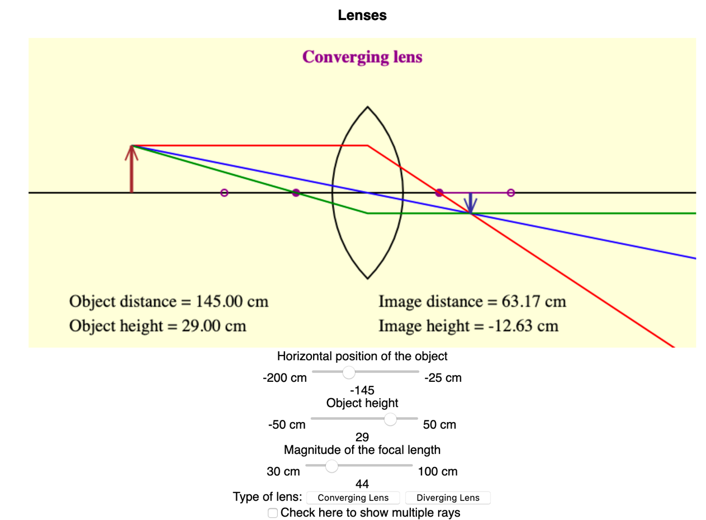
Type of lens
Distance from center of lens to object
Height of object
Focal length

You should remember to use the sign conventions listed in the reading when doing calculations in this lab. The simulation tends to use negative signs (on the object distance, for example) for things that are on the left, even when that doesn’t match those sign conventions.

For a Converging Lens:
- Click the “Converging Lens” button. As you move the focal length of the lens from its smallest value to its largest, leave the object distance and the object height the same.
  - What happens to the image distance?
Ans: Image distance increases from minimum to infinite value then it becomes negative(meaning image forms on the same side as the object, virtual image) and the value keeps on decreasing as we move the focal length of the lens from its smallest value to its largest.
  - What happens to the image height?
Ans: : The value of the image height (the size of the inverted image) increases from minimum to infinite value then it becomes positive(meaning image is virtual image and upright) and the value(or size of the image) keeps on decreasing as we move the focal length of the lens from its smallest value to its largest.
- Now set the focal length to f = 65 cm.For each of the following, where the questions ask you “what happens to the image” you should say whether the image gets larger or smaller through the range indicated; what happens to the location of the image; is the image upright, or inverted?
(Focal length is set at f=65 cm and the object distance is decreased from maximum to minimum and the changes in the image is noted)
 | Object distance decreases from maximum to 2f | Object distance decreases from2f to f | Object distance decreases from f to minimum
Does the image height get larger or smaller as the focal length decreases? | larger | larger | smaller
Does the image distance get larger or smaller as the focal length decreases? | larger | larger | smaller
Is the image upright or inverted? | inverted | inverted | upright

For a Diverging Lens:
- Click the “Diverging Lens” button, and reset the object distance to be in the center of its range. Then, as you move the focal length of the lens from its smallest value to its largest, leave the object distance and the object height the same.
  - What happens to the image distance?
Ans: The value of the image distance increases as we move the focal length of the lens from its smallest value to its largest.
  - What happens to the image height?
Ans: The image height increases as we move the focal length of the lens from its smallest value to its largest.
- Now set the focal length to f = 65 cm. For each of the following, where the questions ask you “what happens to the image” you should say whether the image gets larger or smaller through the range indicated; what happens to the location of the image; is the image upright, or inverted?
(Focal length is set at f=65 cm and the object distance is decreased from maximum to minimum and the changes in the image is noted)
 | Object distance decreases from maximum to 2f | Object distance decreases from2f to f | Object distance decreases from f to minimum
Does the image height get larger or smaller as the focal length decreases? | larger | larger | larger
Does the image distance get larger or smaller as the focal length decreases? | smaller | smaller | smaller
Is the image upright or inverted? | upright | upright | upright

Part 2: Converging and Diverging Mirror Simulations
We will use the simulation at the following site to look at ray diagrams for mirrors:
http://physics.bu.edu/~duffy/HTML5/Mirrors.html
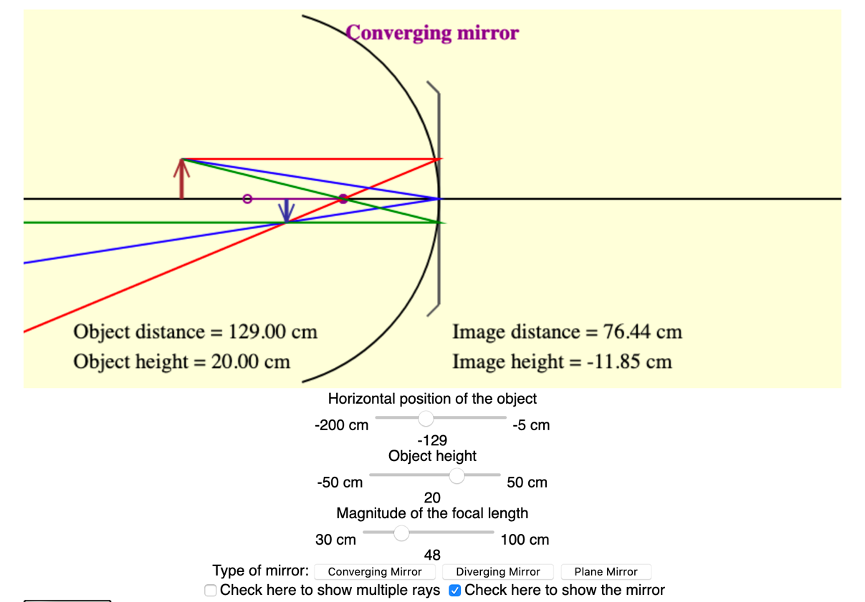
Focal length
Object height
Object distance
To make the curve of the mirror show
Type of mirror

You should remember to use the sign conventions listed in the reading when doing calculations in this lab. The simulation tends to use negative signs (on the object distance, for example) for things that are on the left, even when that doesn’t match those sign conventions.

For a Converging Mirror:
- Click the “Converging Mirror” button, and reset the object distance to be in the center of its range. As you move the focal length of the mirror from its smallest value to its largest, leave the object distance and the object height the same.
  - What happens to the image distance?
Ans: Image distance increases from minimum to infinite value then it becomes negative(meaning image forms on behind the mirror, virtual image) and the value keeps on decreasing as we move the focal length of the lens from its smallest value to its largest.
  - What happens to the image height?
Ans: : The value of the image height (the size of the inverted image) increases from minimum to infinite value then it becomes positive(meaning image is virtual image and upright) and the value(or size) keeps on decreasing as we move the focal length of the lens from its smallest value to its largest.
- Now set the focal length to f = 65 cm. For each of the following, where the questions ask you “what happens to the image” you should say whether the image gets larger or smaller through the range indicated; what happens to the location of the image; is the image upright, or inverted?
(Focal length is set at f=65 cm and the object distance is decreased from maximum to minimum and the changes in the image is noted)
 | Object distance decreases from maximum to 2f | Object distance decreases from2f to f | Object distance decreases from f to minimum
Does the image height get larger or smaller as the focal length decreases? | larger | larger | Smaller
Does the image distance get larger or smaller as the focal length decreases? | larger | larger | Smaller
Is the image upright or inverted? | inverted | Inverted | Upright

For a Diverging Mirror:
- Click the “Diverging Mirror” button and reset the object distance to be in the center of its range. As you move the focal length of the mirror from its smallest value to its largest, leave the object distance and the object height the same.
  - What happens to the image distance?
Ans: The value of the image distance increases as we move the focal length of the lens from its smallest value to its largest.

  - What happens to the image height?
Ans: The image height increases as we move the focal length of the lens from its smallest value to its largest.

- Now set the focal length to f = 65 cm. For each of the following, where the questions ask you “what happens to the image” you should say whether the image gets larger or smaller through the range indicated; what happens to the location of the image; is the image upright, or inverted?
(Focal length is set at f=65 cm and the object distance is decreased from maximum to minimum and the changes in the image is noted)
 | Object distance decreases from maximum to 2f | Object distance decreases from2f to f | Object distance decreases from f to minimum
Does the image height get larger or smaller as the focal length decreases? | larger | larger | larger
Does the image distance get larger or smaller as the focal length decreases? | smaller | smaller | smaller
Is the image upright or inverted? | upright | upright | upright

- Summarize your findings from Parts 1-2 by filling out the table below.
 | Object Distance | Image Height:Larger/Smaller than object? | Orientation:Flipped or Upright? | Image Type: Real or Virtual?
Converging Lenses | $$d_{o}>2f$$ | smaller | flipped | real
Converging Lenses | $$2f<d_{o}<f$$ | larger | flipped | real
Converging Lenses | $$d_{o}<f$$ | larger | upright | virtual
Diverging Lenses | All | smaller | upright | virtual
Part 3: Calculating focal length and magnification for converging and diverging lenses
- For several converging lenses, you are given the following object and image distances. Show your calculations, using the thin lens equation and the magnification equation.
Calculation:
Thin lens equation is given by, $\frac{1}{f}$ = $\frac{1}{d_{0}}$ +$\frac{1}{d_{i}}$
Where d₀ and d_{i} are the object and image distances, respectively, from the mirror or lens plane, and f is the focal length of the mirror or lens. Focal lengths are positive for converging lenses and convex mirrors (shown below), and negative for diverging lenses and concave mirrors.
The convention is that, If we have a real image, d_{i} > 0.
If we have a virtual image, d_{i} <0.

And, magnification , M$=-\frac{d_{i}}{d_{o}}$
The convention here is that negative magnification will indicate that the image is inverted (or flipped) when compared to the object. Positive magnifications indicate that the image is upright (or erect) - it is oriented the same way as the object.
Magnification M > 1, if the image is larger than the object.
Magnification M < 1, if the image is smaller than the object.

(i)Then, for object distance,${ d}_{o}$ = 28 cm and image distance $d_{i}$=-80 cm, we have
$\frac{1}{f}$ = $\frac{1}{d_{0}}$ +$\frac{1}{d_{i}}$ = $\frac{1}{28}$+$\frac{1}{(-80)}$ = $\frac{13}{560}$ Then, f =$\frac{560}{13}$ cm =43.08 cm and M $=-\frac{d_{i}}{d_{o}}$ =-( $\frac{-80}{28}$) = 2.857 , image is larger and upright
(ii) d_{o} =119 cm and d_{i} = 159 cm

$\frac{1}{f}$ = $\frac{1}{d_{0}}$ +$\frac{1}{d_{i}}$ = $\frac{1}{119}$+$\frac{1}{159}$ = $\frac{278}{18921}$ Then, f= $\frac{18921}{278}$ cm =68.06 cm and M=$-\frac{d_{i}}{d_{o}}$ =-( $\frac{159}{119}$) = -1.336, image is larger and flipped
(iii) d_{o} = 187 cm , d_{i} = 163 cm
$\frac{1}{f}$ = $\frac{1}{d_{0}}$ +$\frac{1}{d_{i}}$ = $\frac{1}{187}$+$\frac{1}{163}$ = $\frac{350}{30481}$ Then, f= $\frac{30481}{350}$ cm =87.09 cm and M=$-\frac{d_{i}}{d_{o}}$ =-( $\frac{163}{187}$) = -0.872, image is smaller and flipped

Object distance (cm) | Image distance (cm) | Focal length (cm) | Magnification | Flipped or upright? | Image larger or smaller than object?
28 | -80 | 43.08 | 2.857 | upright | larger
119 | 159 | 68.06 | -1.336 | flipped | larger
187 | 163 | 87.09 | -0.872 | flipped | smaller

- For several diverging lenses, you are given the following object and image distances. Show your calculations, using the thin lens equation and the magnification equation.
Calculation:
(i)Then, for object distance,${ d}_{o}$ = 30 cm and image distance $d_{i}$=-7.5 cm, we have
$\frac{1}{f}$ = $\frac{1}{d_{0}}$ +$\frac{1}{d_{i}}$ = $\frac{1}{30}$+$\frac{1}{(-7.5)}$ = $-\frac{1}{10}$ Then, f =$-\frac{10}{1}$ cm =-10 cm and M $=-\frac{d_{i}}{d_{o}}$ =-( $\frac{-7.5}{30}$) = 0.25 , image is smaller and upright
(ii) d_{o} =24 cm and d_{i} = -11.2 cm

$\frac{1}{f}$ = $\frac{1}{d_{0}}$ +$\frac{1}{d_{i}}$ = $\frac{1}{24}$+$\frac{1}{(-11.2)}$ = $-\frac{1}{21}$ Then, f= $-\frac{21}{1}$ cm =-21 cm and M=$-\frac{d_{i}}{d_{o}}$ =-( $\frac{-11.2}{24}$) = 0.467, image is smaller and upright
(iii) d_{o} = 28 cm , d_{i} = -17.1 cm
$\frac{1}{f}$ = $\frac{1}{d_{0}}$ +$\frac{1}{d_{i}}$ = $\frac{1}{28}$+$\frac{1}{(-17.1)}$ = $-\frac{109}{4788}$ Then, f=- $\frac{4788}{109}$ cm =-43.93 cm and M=$-\frac{d_{i}}{d_{o}}$ =-( $\frac{-17.1}{28}$) = 0.611, image is smaller and upright

Object distance (cm) | Image distance (cm) | Focal length (cm) | Magnification | Flipped or upright? | Image larger or smaller than object?
30 | -7.5 | -10 | 0.25 | upright | smaller
24 | -11.2 | -21 | 0.467 | upright | smaller
28 | -17.1 | -43.93 | 0.611 | upright | smaller

Part 4: Calculating focal length and magnification for converging and diverging mirrors
- For several converging mirrors, you are given the following object and image distances. Show your calculations, using the thin lens equation and the magnification equation.
Calculation:
We use the thin lens formula $\frac{1}{f}$ = $\frac{1}{d_{0}}$ +$\frac{1}{d_{i}}$and M$=-\frac{d_{i}}{d_{o}}$here with the convention
- For a converging mirror (inside the curve)
  - Focal length is positive.
  - For real images, image distance is positive and image is inverted.
  - For virtual images, image distance is negative and image is upright.
- For a diverging mirror (outside the curve)
  - Focal length is negative.
  - Images are upright.
  - Virtual images have negative image distances.

(i)Then, for object distance,${ d}_{o}$ = 28 cm and image distance $d_{i}$=-80 cm, we have
$\frac{1}{f}$ = $\frac{1}{d_{0}}$ +$\frac{1}{d_{i}}$ = $\frac{1}{28}$+$\frac{1}{(-80)}$ = $\frac{13}{560}$ Then, f =$\frac{560}{13}$ cm =43.08 cm and M $=-\frac{d_{i}}{d_{o}}$ =-( $\frac{-80}{28}$) = 2.857 , image is larger and upright
(ii) d_{o} =35 cm and d_{i} = 169 cm

$\frac{1}{f}$ = $\frac{1}{d_{0}}$ +$\frac{1}{d_{i}}$ = $\frac{1}{35}$+$\frac{1}{169}$ = $\frac{204}{5915}$ Then, f= $\frac{5915}{204}$ cm =28.995 cm and M=$-\frac{d_{i}}{d_{o}}$ =-( $\frac{169}{35}$) = -4.829, image is larger and flipped
(iii) d_{o} = 19 cm , d_{i} =17.1 cm
$\frac{1}{f}$ = $\frac{1}{d_{0}}$ +$\frac{1}{d_{i}}$ = $\frac{1}{19}$+$\frac{1}{17.1}$ = $\frac{1}{9}$ Then, f= $\frac{9}{1}$ cm =9 cm and M=$-\frac{d_{i}}{d_{o}}$ =-( $\frac{17.1}{19}$) = -0.9, image is smaller and flipped

Object distance (cm) | Image distance (cm) | Focal length (cm) | Magnification | Flipped or upright? | Image larger or smaller than object?
28 | -80 | 43.08 | 2.857 | upright | larger
35 | 169 | 28.995 | -4.829 | flipped | larger
19 | 17.1 | 9 | -0.9 | flipped | smaller

- For several diverging mirrors, you are given the following object and image distances. Show your calculations, using the thin lens equation and the magnification equation.
Calculation:
(i)Then, for object distance,${ d}_{o}$ = 33 cm and image distance $d_{i}$=-20.2 cm, we have
$\frac{1}{f}$ = $\frac{1}{d_{0}}$ +$\frac{1}{d_{i}}$ = $\frac{1}{33}$+$\frac{1}{(-20.2)}$ = $-\frac{64}{3333}$ Then, f =$-\frac{3333}{64}$ cm =-52.08 cm and M $=-\frac{d_{i}}{d_{o}}$ =-( $\frac{-20.2}{33}$) = 0.612 , image is smaller and upright
(ii) d_{o} =30 cm and d_{i} = -13.0 cm
$\frac{1}{f}$ = $\frac{1}{d_{0}}$ +$\frac{1}{d_{i}}$ = $\frac{1}{30}$+$\frac{1}{(-13.0)}$ =- $\frac{17}{390}$ Then, f= $-\frac{390}{17}$ cm =-22.94 cm and M=$-\frac{d_{i}}{d_{o}}$ =-( $\frac{-13}{30}$) = 0.433, image is smaller and upright
(iii) d_{o} = 25 cm , d_{i} =-8.1 cm
$\frac{1}{f}$ = $\frac{1}{d_{0}}$ +$\frac{1}{d_{i}}$ = $\frac{1}{25}$+$\frac{1}{-8.1}$ =- $\frac{169}{2025}$ Then, f= $-\frac{2025}{169}$ cm =-11.98 cm and M=$-\frac{d_{i}}{d_{o}}$ =-( $\frac{-8.1}{25}$) = 0.324, image is smaller and upright

Object distance (cm) | Image distance (cm) | Focal length (cm) | Magnification | Flipped or upright? | Image larger or smaller than object?
33 | -20.2 | -52.08 | 0.612 | upright | smaller
30 | -13.0 | -22.94 | 0.433 | upright | Smaller
25 | -8.1 | -11.98 | 0.324 | upright | smaller

